Practical Test-1 Windows App Development Using .Net MM: 10

(Even Students)

Part-A

A restaurant wants an app that calculates a table’s bill. The app should display all the menu items from Fig. 15.53 in four ComboBoxes. Each ComboBox should contain a category of food offered by the restaurant (Beverage, Appetizer, Main Course and Dessert).  
  
The user can choose from one of these ComboBoxes to add an item to a table’s bill. As each item is selected in the ComboBoxes, add the price of that item to the bill. The user can click the Clear Bill Button to restore the Subtotal:, Tax: and Total: fields to $0.00.

Menu Item Category Price ($)

Soda Beverage 1.9

Tea Beverage 1.5

Coffee Beverage 1.25

Mineral Water Beverage 2.95

Juice Beverage 2.5

Milk Beverage 1.5

Buffalo Wings Appetizer 5.95

Buffalo Fingers Appetizer 6.95

Potato Skins Appetizer 8.95

Nachos Appetizer 8.95

Mushroom Caps Appetizer 10.95

Shrimp Cocktail Appetizer 12.95

Chips and Salsa Appetizer 6.95

Chicken Alfredo Main Course 13.95

Chicken Picatta Main Course 13.95

Turkey Club Main Course 11.95

Lobster Pie Main Course 19.95

Prime Rib Main Course 20.95

Shrimp Scampi Main Course 18.95

Turkey Dinner Main Course 13.95

Stuffed Chicken Main Course 14.95

Seafood Alfredo Main Course 15.95

Apple Pie Dessert 5.95

Sundae Dessert 3.95

Carrot Cake Dessert 5.95

Mud Pie Dessert 4.95

Apple Crisp Dessert 5.95

[hint: property needs to be checked is combobox1.SelectedIndex==index value]

Sample Interface:

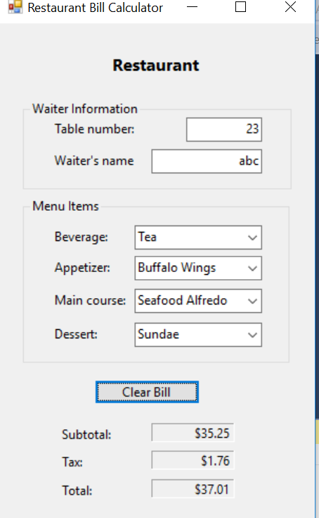

Lab-5

Ques: 1 create a number guess game where computer picks a number randomly between 1 and 100. Then asks user to guess the number.

Enter a number between 1 and 100(0 to quit) : 56

Low,try again. Background of form should be red

Enter a number between 1 and 100(0 to quit): 67

high,try again. Background of form should be yellow

Enter a number between 1 and 100(0 to quit): 59

You guessed it! The number was 59 Background color of form should be green

It took you 2 tries